Tarot Activity 20
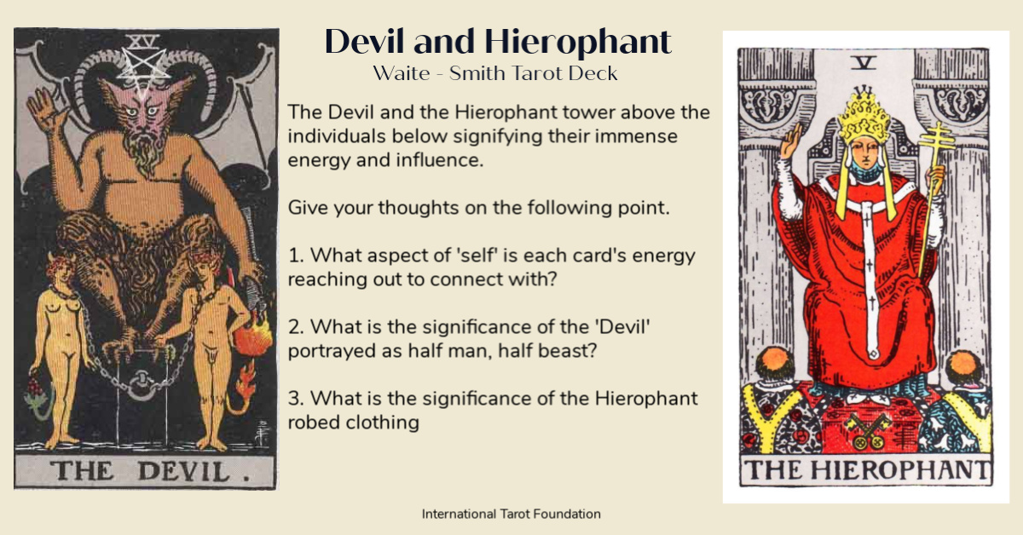
Please add your response in the box below

International Tarot Foundation

