Relationship Dynamics-Exercise 19
King of Pentacles in the past position and Knight of Pentacles in the future. This represents a relationship that is technically over, but the man still has responsibilities.
The question is, does this reading show that he will keep to them?

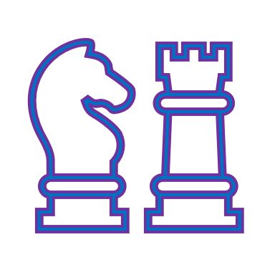
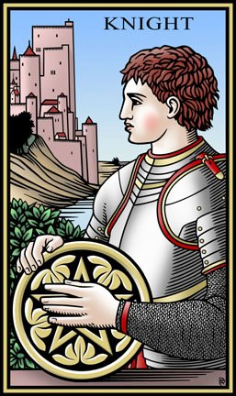
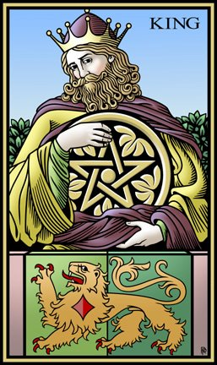
Tarot of the Sevenfold Mystery

Comment on your thoughts below please

International Tarot Foundation-Lara Houston

